Embedded C Lesson 2

Lab 1

Yasmin Mostafa Abdelazem

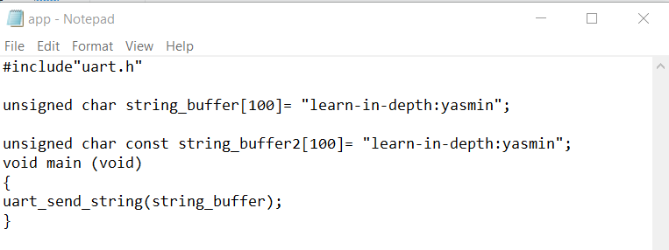App.c

App.o objdump .exe

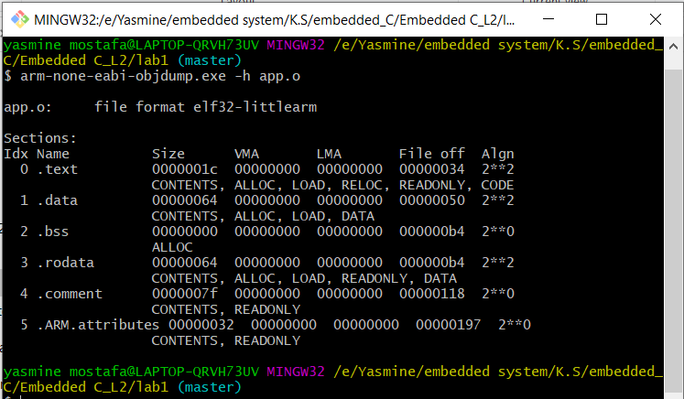

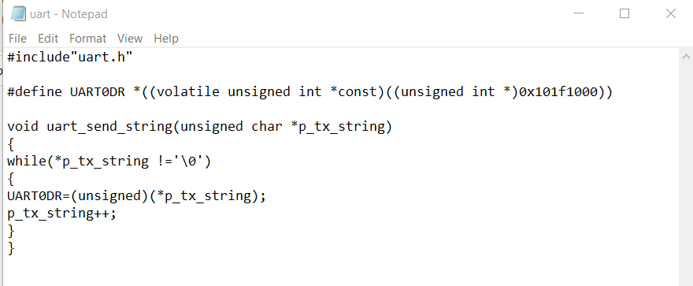uart.c

cc

Uart.h

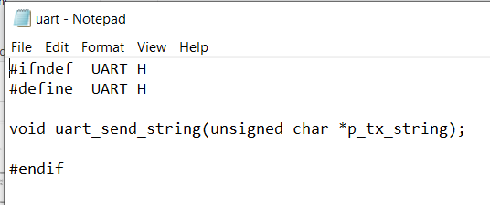

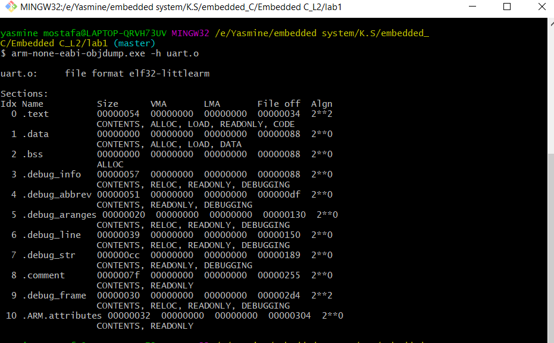Uart.o objdump .exe

Linker_script.ld

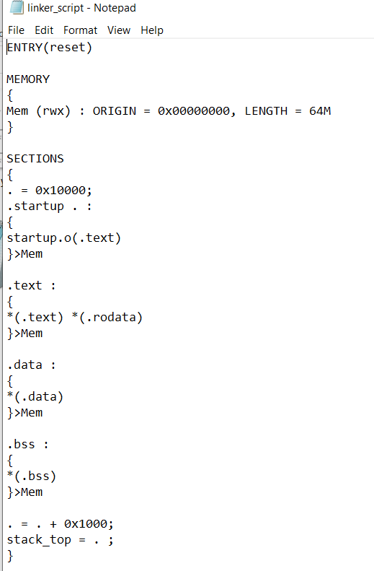

Learn-in-depth objdump

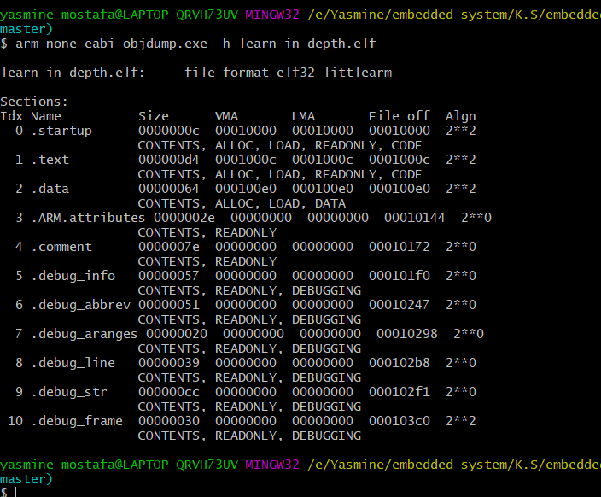

Learn-in-depth objdump

Output in qemu

